8.78: The speed of the block after the bullet has passed through (but before the block has begun to rise; this assumes a large force applied over a short time, a situation characteristic of bullets) is

The final speed of the bullet is then

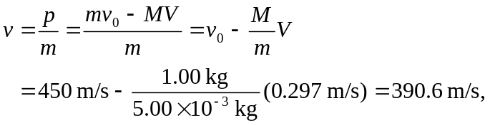
or 390 m/s to two figures.

